Compiled by

Adam Stagg

Owens Nicolas

Alexander Morales

Payton Green

Cameron Stewart

(WIP) Project N

Last updated: June 13, 2021

# Overview - Executive summary

## Elevator Pitch / High Concept

A single-player stealth game featuring multiple exploration options featuring different paths to take in each level and puzzle-solving to unlock said paths. Player controls a Ninja as they infiltrate a palace overrun with Soldiers to collect the Sword of the Ancients.

## Genre

Third person stealth puzzle adventure

## Key/Exotic Features

* Ability to sneak / hide.

Allow the player to cling to walls / objects to sneak and hide around them avoiding detection from the enemies. Could be dynamic with all objects or with colliders on specific spots where stealth is intended.

* Ninja Arsenal

A collection of different abilities the ninja can use to gain advantages in the level. Crow for overhead birds-eye view of the map, kunai for distant stunning / KO of enemies

* Branching paths

Allows the player to pick different paths to advance to the next level, allowing for differing dynamic interactions in later levels.

## Target Audience

Primary:

Everyone 10 and up who are interested in ninja, stealth, and problem-solving puzzles.

Secondary:

People who are into more slow, methodical types of adventure games

## Play Action and Cadence

Slow stealth game, actions matter and you need to take it slow and plan your approach.

## Win Condition / Player Goal

Get to the center of the facility, obtain the special item (sword / gem / treasure) and make it out without dying.

## Loss Condition / Continuation

Spotted by enemy causes enemies to rush to that area, if slashed by a sword, reset to the nearest checkpoint.

# Comparable products

### Assassin’s Creed

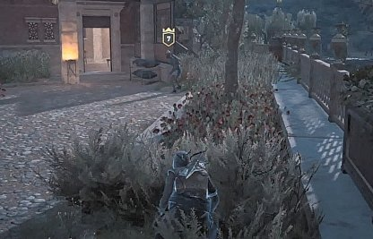

Stealth mechanics relating to cover, enemy can’t detect player when in cover

### Aragami

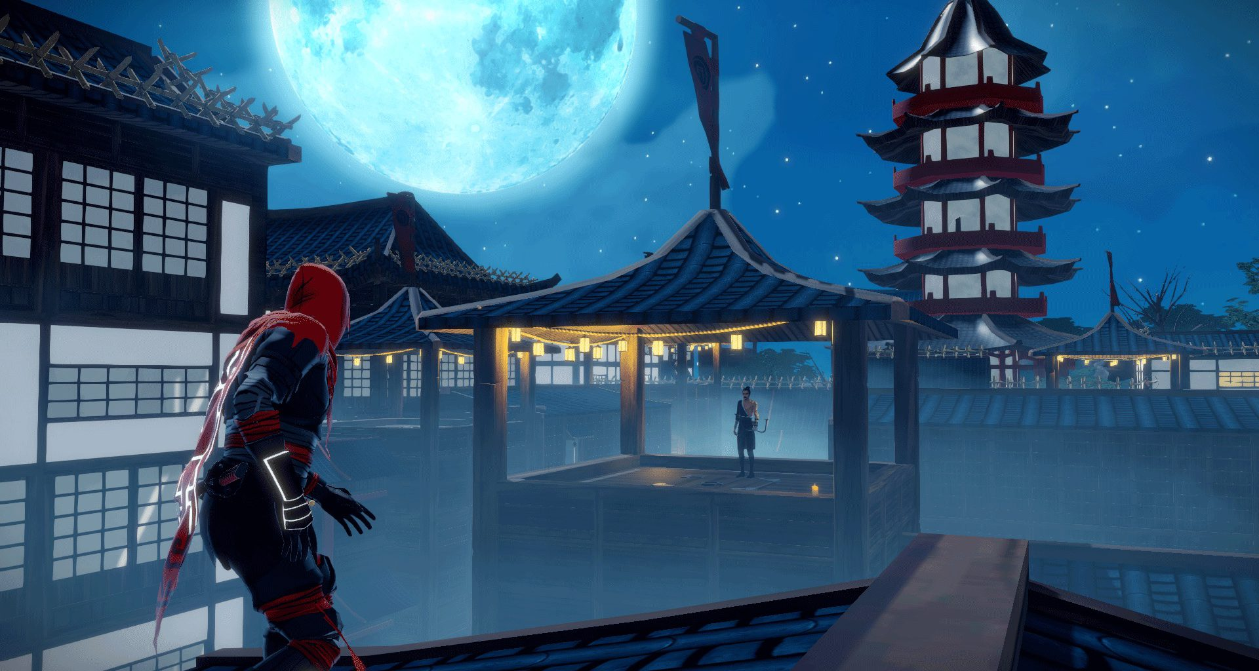

Design/aesthetic. Level Design and overall theming

Level design where the ninja can run around / hide from enemies

### Persona

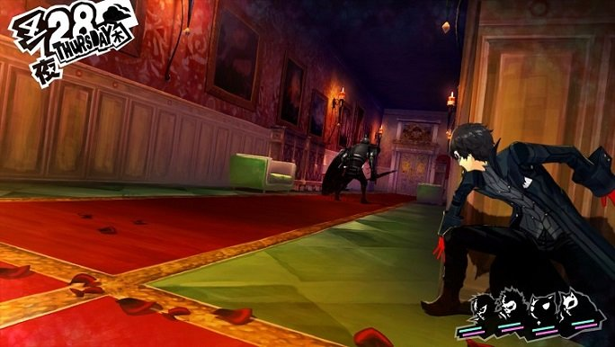

Stealth mechanics. Player can hide against walls and sneak around enemies

### Hitman

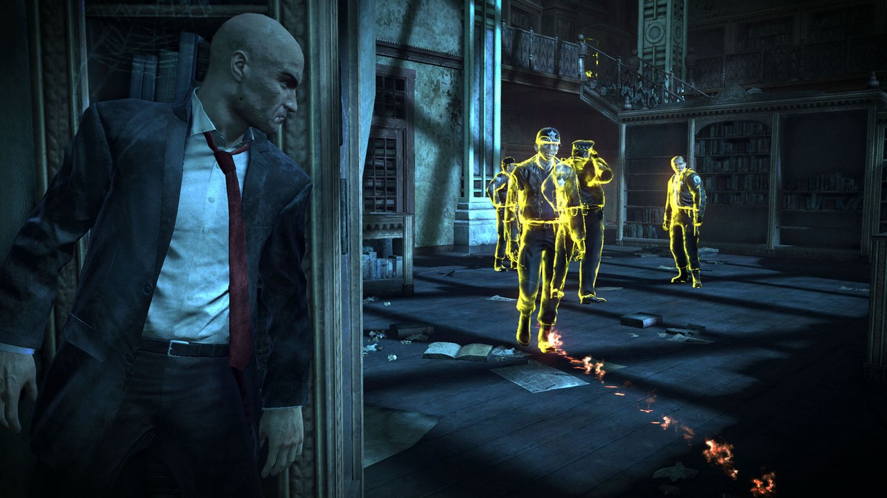

Enemy highlighting, HUD for enemy direction with stealth circle

### CS:GO

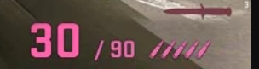

UI for kunai count, shows kunai’s individually

## Art and Production Design

### Colors

Dark color scheme, to symbolize the mystery/ninja’s aesthetic



### Art / visual Style

Inky/ watercolor. Soft lines that make a coherent look, rather than sharp edges and contrast

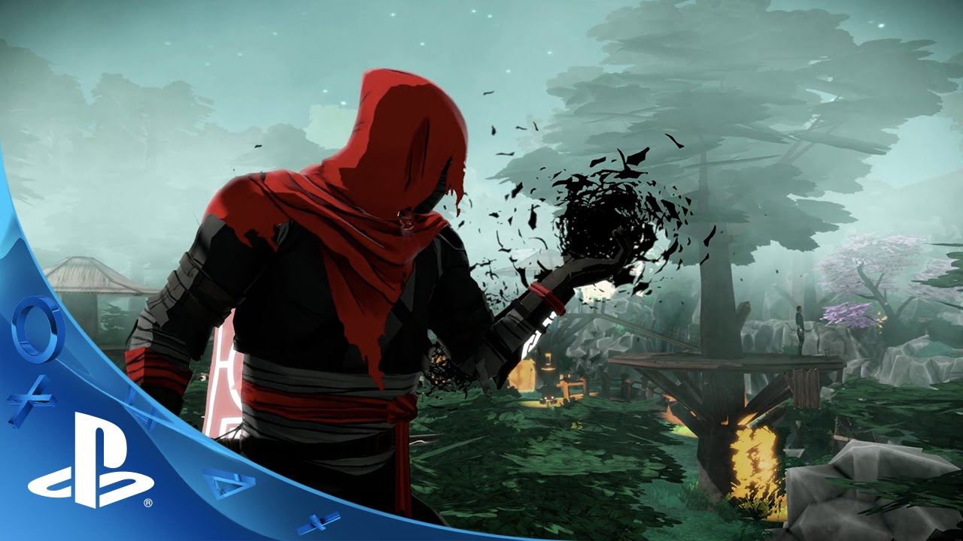

### Music Style

Soft traditional Asian music. Possibly dynamic music that gets tense when near enemies

<https://www.youtube.com/watch?v=VSMaT2MOFkw>  
<https://www.youtube.com/watch?v=zoTIspKDls0&t=74s>

### SFX Style

Realistic sounding, Eccentric to make the player feel impactful.

<https://youtu.be/pmVSl4MTn4g?t=1980>

# Interactivity

## Camera Logic

Third person hard attached camera, that allows for glancing around corners, follows the main player.

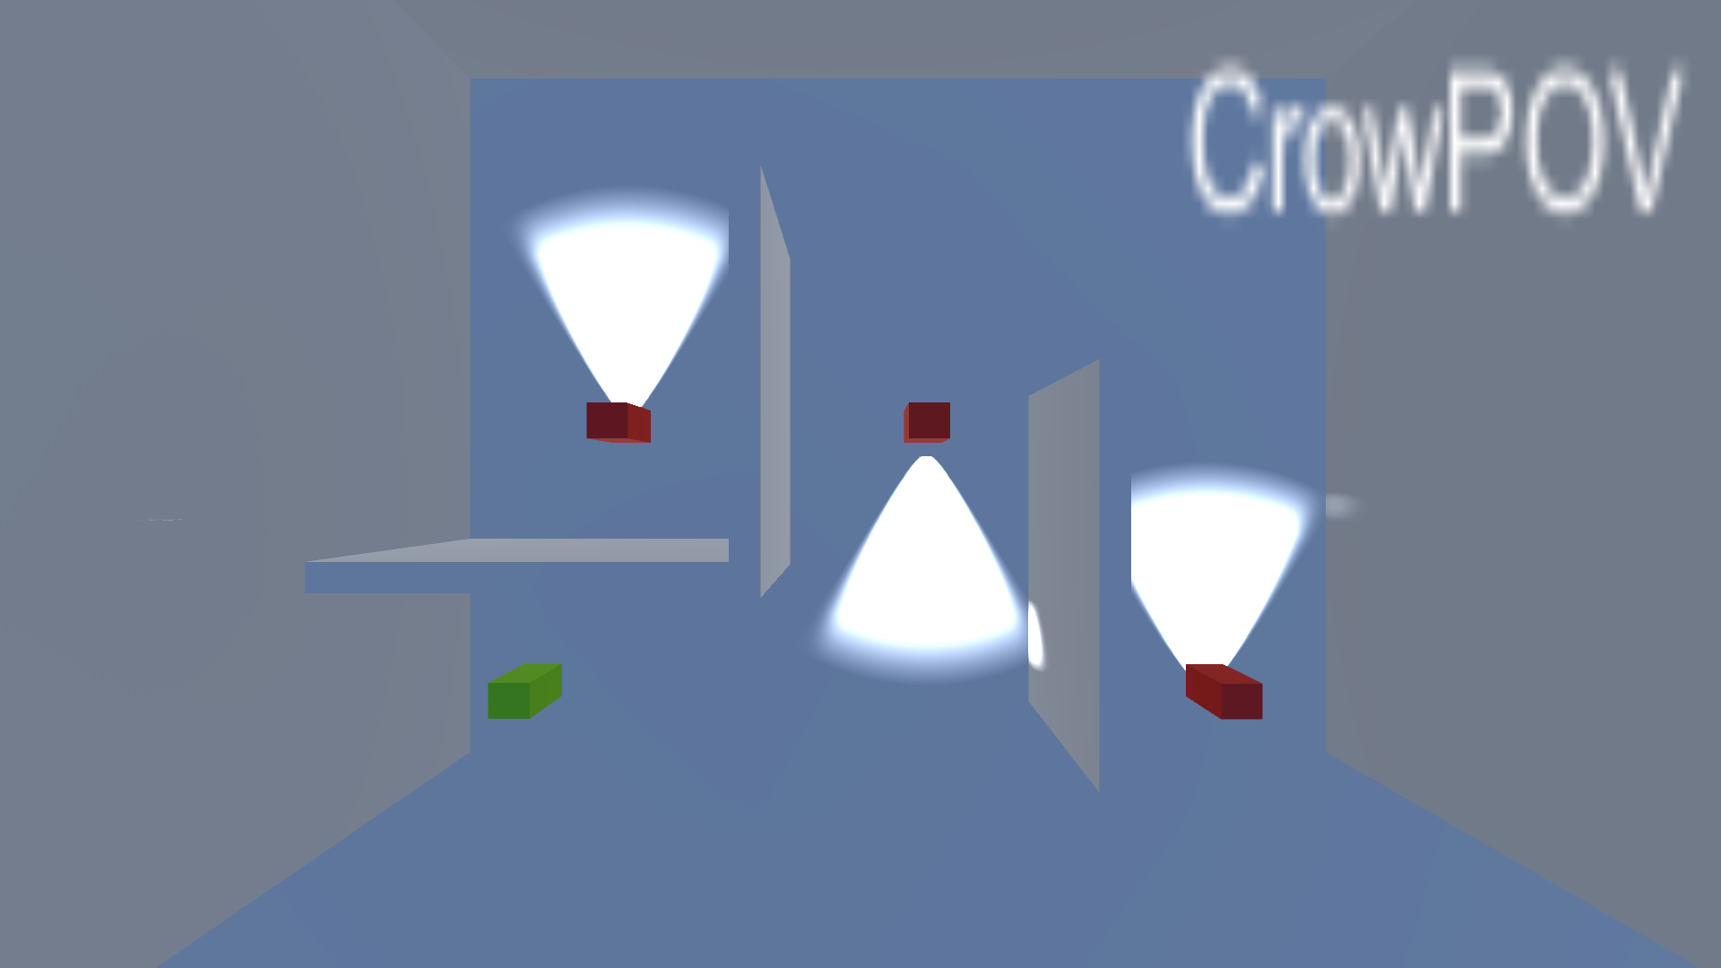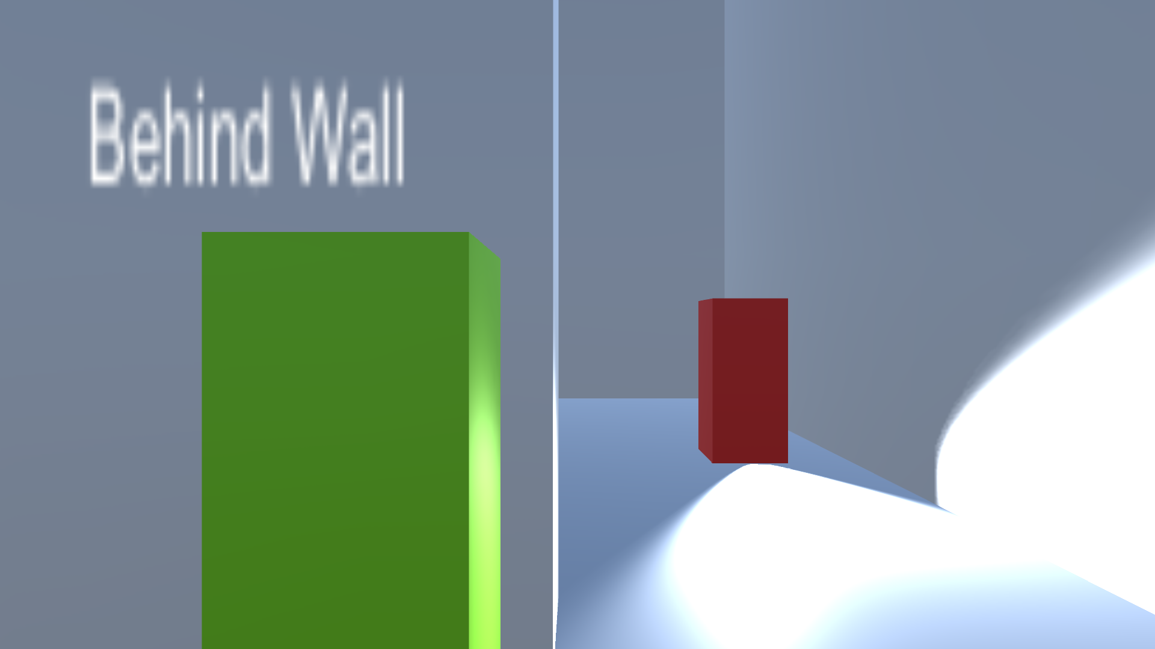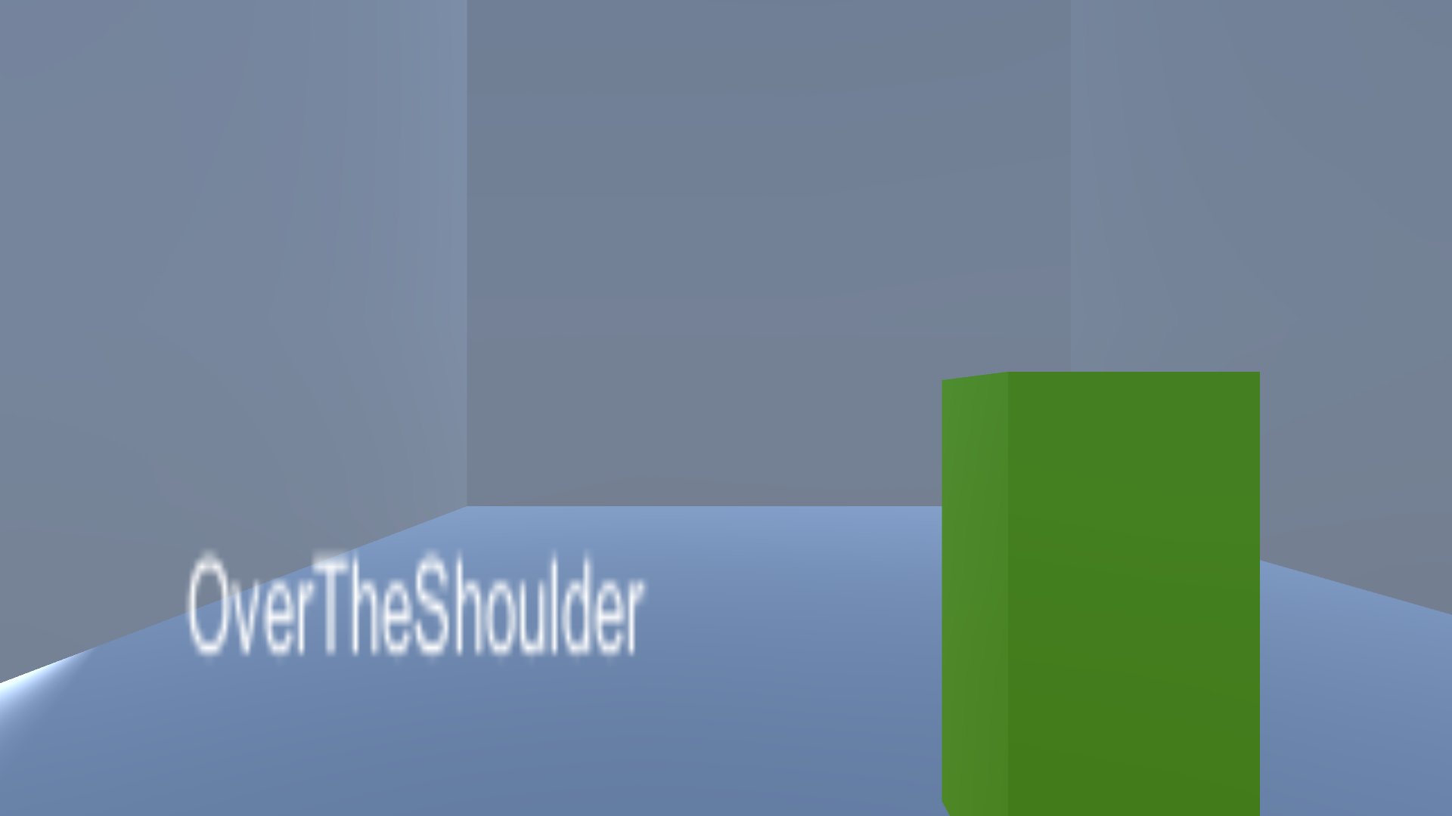

Life-sized. Player should take up about 1/3 of the screen at maximum

Camera follows the player over the shoulder, and clamps when behind a wall to show around the corner.

Arial birds-eye view for the minimap / crow POV

Follow camera:  
 Should be an over the shoulder look, soft attach to the player, allow for rotating without moving the character.

Look around corner camera:

Activates when the player enters stealth mode on a wall. The camera is clamped to look in the direction facing the wall. Allow the camera to swivel to have the player on the left or the right side of the screen, leaving about 2/3 of the screen on the opposite side. Allow for rotation of the camera without moving the character’s rotation

## Controls

### PC Controls

* WASD movement
* Mouse move camera
* LShift - run
* LControl sneak / crouch
* F – Throw Kunai
* Left Click – Attacks (stealth kill, throw kunai when aiming)
* Right Click – Zoom camera / Aim mode
* E – Interact (door, explosive, etc.)
* Escape – Bring up pause menu

### WebPlayer Controls

* WASD movement
* Mouse move camera
* LShift - run
* LControl sneak / crouch
* F – Throw Kunai
* Left Click – Attacks (stealth kill, throw kunai when aiming)
* Right Click – Zoom camera / Aim mode
* E – Interact (door, explosive, etc.)
* Escape – Exit web player

## Scope

### Game Progress – Player Milestones

1. Progress through the introductory section of level 1
2. Infiltrate village to go to Palace Garden
3. Enter palace gardens before actually going into the palace
4. Infiltrate palace and obtain Sword of Ancients
5. Escape Palace with Sword of Ancients

### Worlds/Levels

* 3 Levels
  + Introductory Area + Village Area
    - A Linear introductory area teaching players the mechanics of the game
    - Village area overrun with soldiers. Many houses, porches, a pier and the giant wall separating the village from the palace. Features a secret passageway into the palace.
  + Palace Gardens
    - A giant garden with a hedgemaze, Chinese shrines, open park areas, and gates. Gardening shed and at level end is a giant door leading into palace.
  + Palace Interior
    - A giant palace, with lots of corridors and rooms patrolled by soldiers. Has the Sword of the Ancients in a room in the 2nd stories.
* Each level 5-10 minutes. If optimal play, 5 mins per level.
* Playthrough is 30-60 mins of Total play time.

# Mechanics

## Combat

Ninja dies in 1 hit, but so do all enemies. To take out an enemy, the ninja must approach the enemy from behind and perform a takedown. Ninja has ninja arsenal as special abilities that allow them to progress through the level:

## nINJA aRSENAL (Player Abilities)

### **Kunai**

A small weapon that can be thrown long distances and take out enemies from afar. Consumable

### **CROW**

Gives Xray vision of the entire level. Reveals enemy positions and interactable objects. On a meter that is replenished on enemy takedown.

### **DISTRACTION**

Tosses a small item at a target place. If Guard is nearby, Guard walks over to target place. Consumable.

## Enemy archetypes

* **MELEE**
  + Regular Guards. Nothing Special.
* **RANGED**
  + Are able to take out Ninja from a distance.
* **STANDSTILL**
  + Have a vision cone all around them. Stand in one spot.

## Security Level

*Bar that every guard has. Fills up if Player is in Enemy vision cone. Fill speed depends on range between player and enemy.*

*Has different states depending on how much the bar is filled:*

**PATROL STATE**

**Security Level: 0%**

Guard walks back and forth in assigned path.

**SUSPICIOUS STATE**

**Security Level: 50%**

Guard ponders for 2 seconds, then walks over to position player was in when SLevel reached 50%

**ALERT STATE**

**Security Level: 100%**

Guard is shocked for 2 seconds, then calls over all guards in the immediate area to search the area.

## Obstacle types

**Water**

Player is unable to walk over it but enemies are still able to see over it.

**Locked Door/Gate**

Player is unable to pass through door/gate. Requires Keycard or button press to open

**Laser Gate**

Player dies if touched by laser gate. Will be periodically turned on and off.

**Camera**

Camera shines on a specific area. When spotted, guards around it will slowly increase security levels.

**Spotlight**

Shines on specific area. When spotted, guards will immediately go to area in Alert Mode.

## Player actions

**AGAINST WALL**

Ninja slides against wall, minimizing hitbox from vision cones.

**LADDER**

Interacts with object to change elevation

## Puzzles & Consequences

*Players have multiple ways of getting into the levels, each with their own puzzles and consequences on the next level:*

**Village: Drain the Well**

Player needs to find 3 buttons around the level. Will drain Well unlocking a hidden passageway into palace garden.

**Consequence:** Draining the well requires jamming the mechanism with a kunai. Leaving you with x - 1 max kunais for the rest of the game.

**Gardens: Window Entrance on Roof**

Player needs to find a rope and hook in the gardening shed and, in the tool, shed in order to make a grappling rope.

**Consequence:** The rope will eventually be found outside causing more enemies to patrol the second floor.

**Village: Explosive on Wall**

Player must find an explosive in fireworks shop in village. Break open a broken wall.

**Consequence:** Debris spread throughout palace gardens preventing access through certain routes in the level. Plus, enemy security states will go up 10% faster.

**Gardens: Sneak in through Hay**

Player must find 3 stacks of hay around the level and put them in a wheelbarrow. Allowing them to sneak into the stables of the palace by having a guard ferry them to palace stables.

**Consequence:** Spawns further from Sword of Ancients room on 1st floor, meaning you’ll face more obstacles on the way to the room.